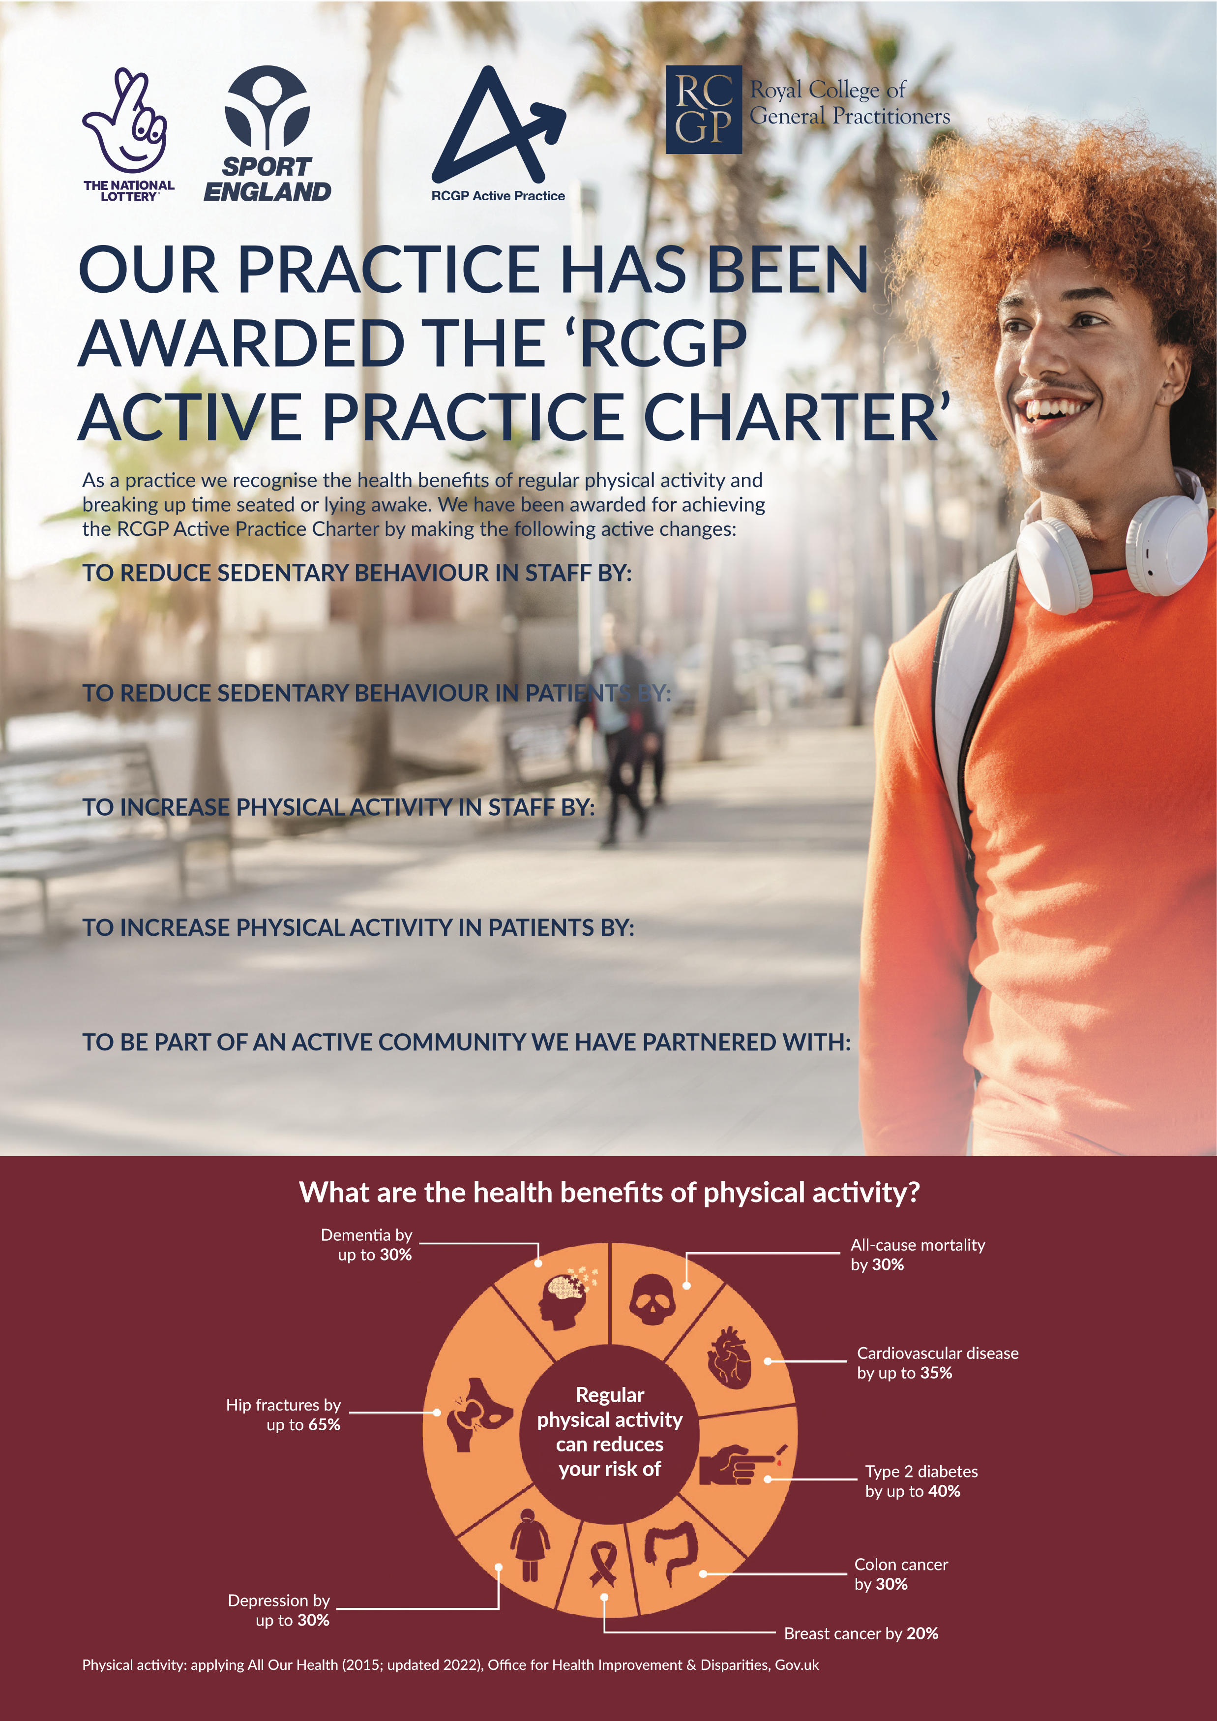
Our Patient Participation Group and local community wellbeing initiatives.
Promoting physical activity through patient information, signposting and health advice.
Supporting active travel and staff wellbeing activities.
Clinicians collecting patients directly from the waiting room rather than using a call system.
Providing sit/stand workstations.

